|  |
| --- |
| Day 4 ( Responsive website ) |

**Task 1**

Create a responsive html page with bootstrap for below layout.

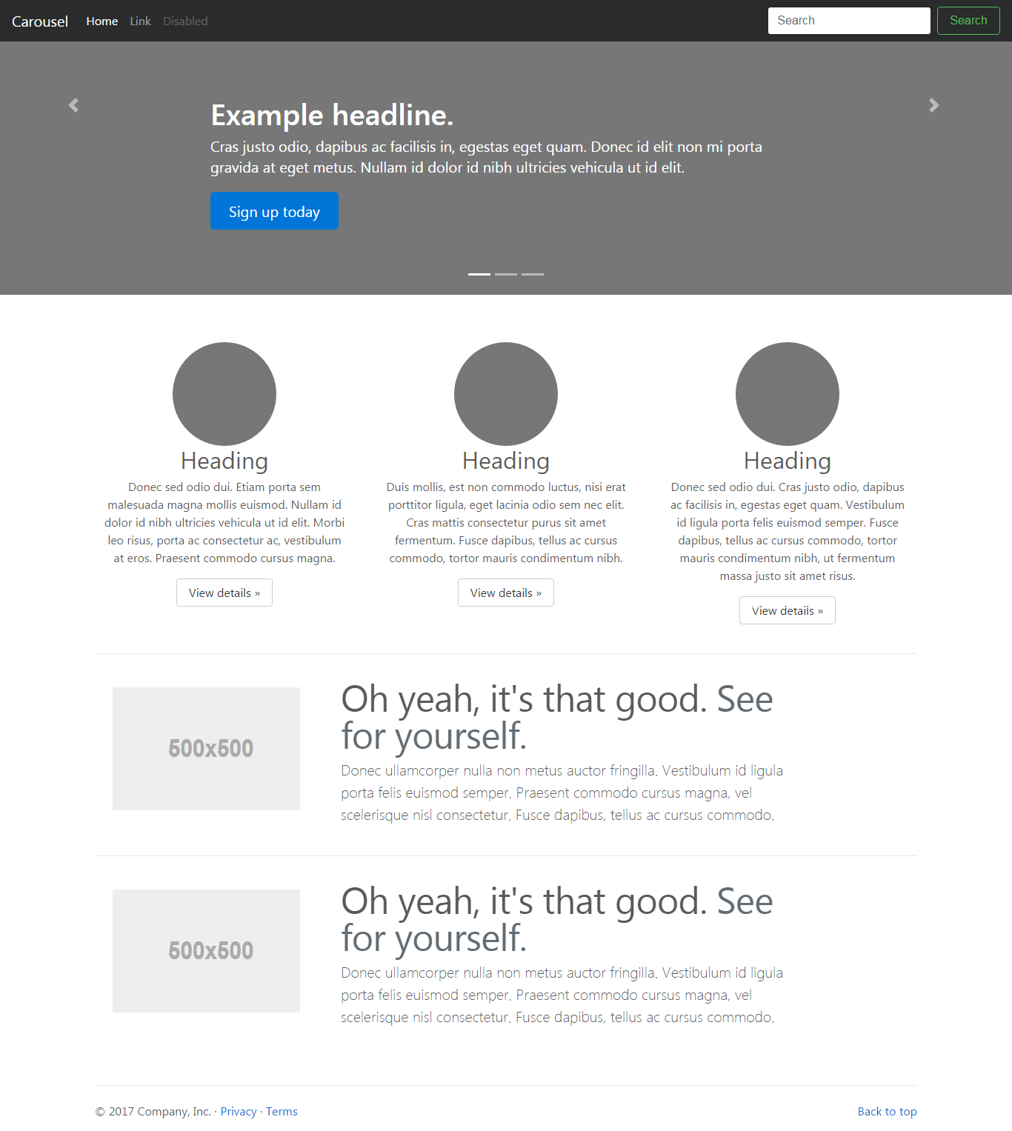

**Task 2**

Create a responsive html page with bootstrap for below layout.

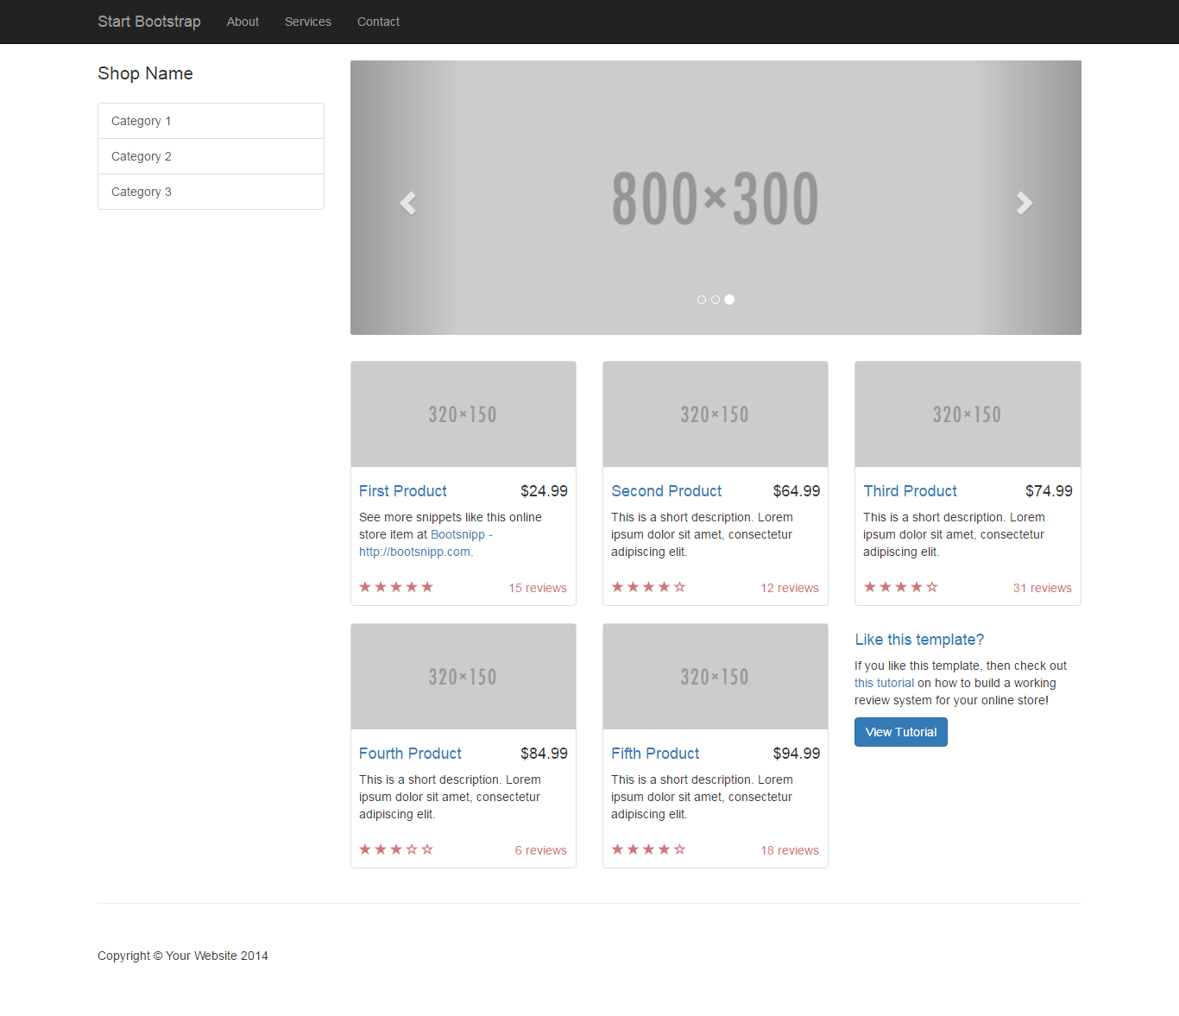

**Task 3**

Create a responsive html page with bootstrap for below layout.

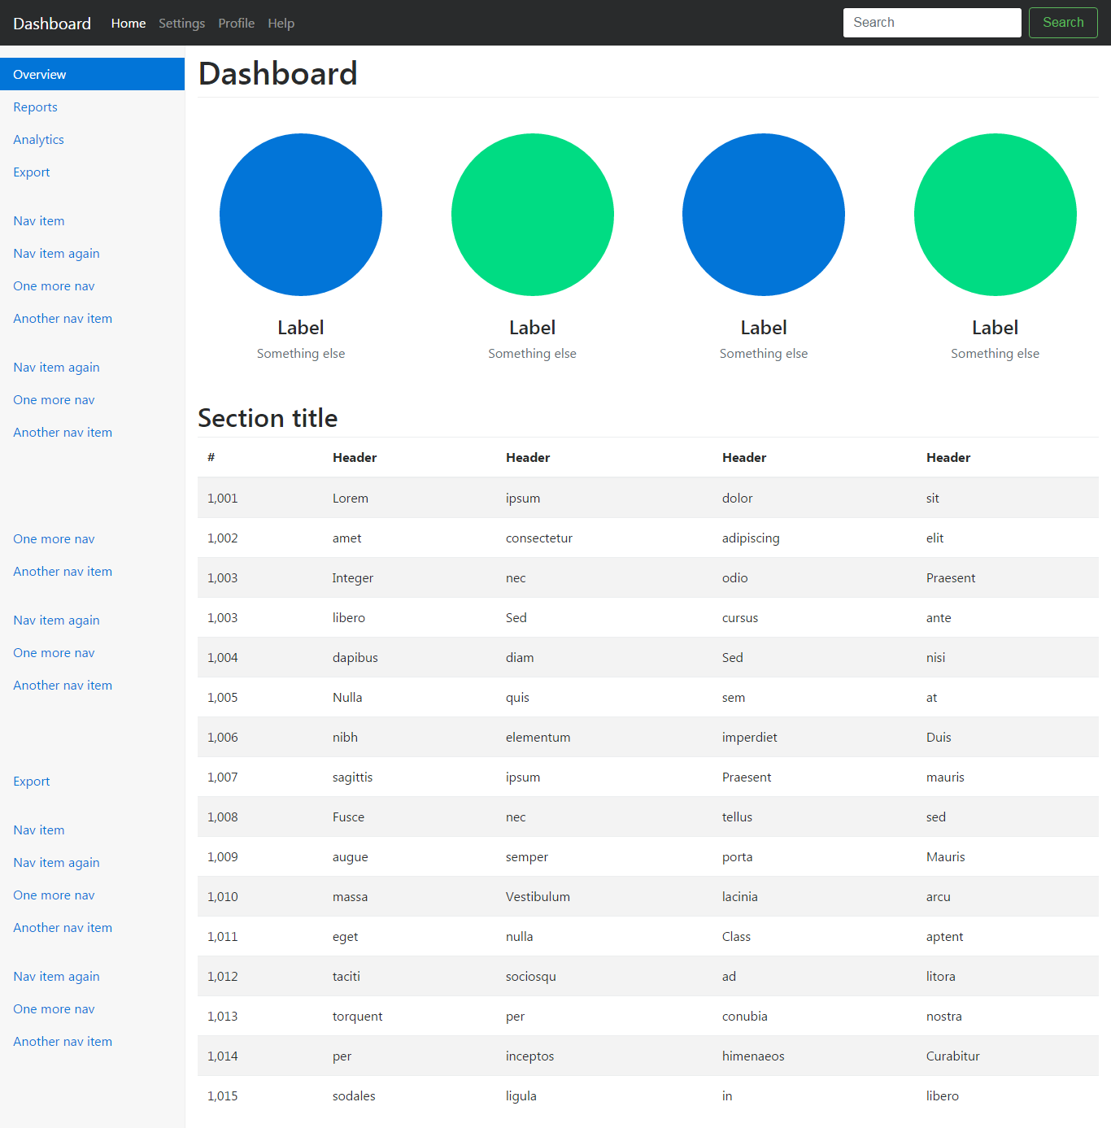

**Task 4**

Create a responsive html page with bootstrap for below layout.

